# JPMorgan Chase Job-Position Test.

## Simplest Solution

In the following lines I'll introduce a little, about how I've realized the test instruction.

# Developing approach:

I've been focused on good practices programming in spite of strong use of framework.

This approach could support a non functional requirements as availability, scalability, and so on.

No multithreading approach has been adopted: one thread per task.

## Data Model:

1. I assume a data structure about the Stock Data on Dividend, ParValue and so on.
2. I assume a data structure about trade recording.
3. I assume a data structure about last 15Minutes trade recording.

**a-** will contains mocked data about a stock's information not so frequently changes.

**b-** will contains data about a single trade execution, the last one just recorded.

**c-** will contains data about trades happened in the last 15 minutes.

this data structure will always contain the trades belonging to the last 15 minutes range,

trades off the range will be discarded. Surely before the trade cutting off 15minutes range,

we could make a persistent storage in somewhere.

with this approach the data can be divided and stored as need, the la 15 minutes trade extraction

don't consume resources and time.

## Simple use case for testing propouse:

Recording a single trade on 'b-' will impact a trade recording in '-c' and check about 15Minutes range consistence.

If the new trade will extends the range over 15Minutes one or more transaction will be discarded.

## Misc Details:

Dividend Data Calculation: based on a- data structure.

P/E Ratio Calculation: based on a- data structure

The TickerPrice as been calculated as 0.1 * ParValue.

GBCE index has been calculated on c- data structure.

StockProce Calculation: based on c- data structure.

# Coherence Based Solution.

**Introduction**:

Coherence is a flexible distributed HasMap of ORACLE bundled with Weblogic release. This software provide an API for Coherence-HashMap management and the consistence between replicas is in charge to ORACLE private protocol.

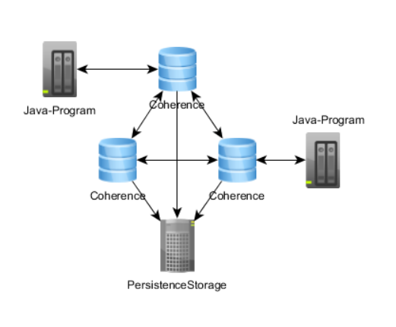

With this approach you’ll have all benefit of distributed architecture: fault tolerant, horizontal scalability and so on…

Obviously Coherence could be replaced with other products.